## 

## 

## 

## 

## 

## 

Stoic Solutions

## 

## 

## 

## 

## 

## 

## 

Team (stoicsolutionscsusm@gmail.com):

Adam Hebel, Brian Rattanasith, Chris Bertram, Connor Myers,

Enrique Jimenez, Jerry Compton, Jordan Mower, Matthew Adamus

**Table of Contents**

**Stoic Solutions Code of Conduct** 3

**1. Application Development** 4

1.1 Statement of Business Context 4

1.2 Statement of Customer’s Business Problem 4

1.3 Statement of Project Proposal 4

1.4 Statement of Deliverables 4

1.5 Measures of Success 5

1.6 System Overview 5

**2. Requirements Matrix** 6

**3. Project Management** 6

3.1 Initial Schedule for Tasks and Deliverables 6

3.2 Statement of Total Price 9

3.3 Gantt Chart 10

3.4 Initial Project Cost Tracking Chart 13

3.5 Statement of Deliverables 14

3.6 Outline of Resources Needed 14

**Team Information** 15

To: Dr. Kristin Stewart, Assistant Professor of Marketing

CC: Dr. Shaun-inn Wu, Director of Projects

Stoic Solutions is thrilled to be a part of this amazing project for Keep America Beautiful. Thank you, Dr. Stewart, for providing us with this opportunity to be a part of not only a fun and engaging project but also a great cause. We looked forward to continuing our work with you this semester and making this project come to fruition.

The first phase involved the team conducting research and finding the requirements needed for the database to be created and how the database should be categorized. The requirements are as follows: Collect data from 360 google street images, process the images with the existing algorithm, define the data and geographic space, lastly, make it available for the UI team to use. In the next phase we plan to dig deeper into the requirements and then start implementing and testing ways to identify a geographical location so that we can have a functional and usable database filled with data for the UI team to utilize.

Regarding the accrued and projected cost of this project. Our team will be operating at a rate of $28.00 per hour. Our estimated total cost, which includes our hourly rate and the cost of running the AWS server, amounts to $17,128.30.

A copy of this report will be submitted to both Dr. Stewart and Dr. Wu

By signing below, you hereby approve Stoic Solutions to continue working on the following project: Keeping America Beautiful: Litter Detective and agree to the aforementioned estimated costs.

__________________________________________________

*Dr. Kristin Stewart, Assistant Professor of Marketing*

# **Stoic Solutions Code of Conduct**

**Mission:** The team mission at Stoic Solutions is to create a positive, collaborative, and conscientious atmosphere to ensure project deadlines and goals are met.

**Decisions:**

* Every team member has equal say in the decisions that will affect the group and project.
* It is expected that every member will support the group's decisions, regardless if they agree with them or not in order to form a unified team.
* Disagreement over decisions are welcome, as they often result in the best solution for a problem. However, disagreements should not lead to arguments and should be handled in a professional manner.

**Work Ethic/Teamwork:**

* No person should feel alone on this project. Although every group member has assigned tasks, it is encouraged to work together to complete these tasks to achieve our common goal.
* The tasks needed to complete this project will not be completed by a few members, this is a group project and will be completed by the group.

**Meetings:**

* Every member of the team is expected to make time for mandatory group meetings, and attend said meetings once they are agreed upon.
* In the event that a team member cannot attend a meeting, it is their responsibility to be up to date with all events and decisions made during the meeting.
* It is expected that every person in the meeting will be engaged and behave in a professional and respectful manner.

# **1. Application Development**

## 1.1 Statement of Business Context

Keep America Beautiful is a national non-profit organization that strives to improve, educate, and beautify both the environment and people. With more than 600-community based affiliates, partners, volunteers, and more, they are able to perform just so.

## 1.2 Statement of Customer’s Business Problem

* Keep America Beautiful needs the data produced by the algorithm to mean something.
* Needs the data produced to have a rating system.
* The definition of a geographical space must be defined to signify cities, counties etc.
* Make the data available and usable for the UI team.

## 1.3 Statement of Project Proposal

* Goal 1 - Collect data from 360 Google Street images.
* Goal 2 - Process images through ML.
* Goal 3.1 - Collect output data.
* Goal 3.2 - Define what a geographic space is.
* Goal 4 - Make data accessible to the UI team.

On behalf of Dr. Kristin Stewart we will implement the following with the intent of making this data usable and available to the UI team.

## 1.4 Statement of Deliverables

* Database filled with all data produced by the existing algorithm for UI team usage.
* Data will include:
  + Total litter in given area.
  + Geographic space.
  + Litter rating of 1 to 4.

## 1.5 Measures of Success

**JAD 1 -** Identify requirements of the project.

**JAD 2 -** Finalize requirements of the project.

**Phase 1 (Prototype 1) -** Able to label and store images for a defined geographic region

**Phase 2 (Prototype 2) -** Process images with ML algorithm, produce litter metrics, and delete stored images.

**Phase 3 (Final Product)** **-** Collation, transfer and storage of litter metrics from GSV360 images that have been processed through a machine learning algorithm for use by UI team.

## 1.6 System Overview

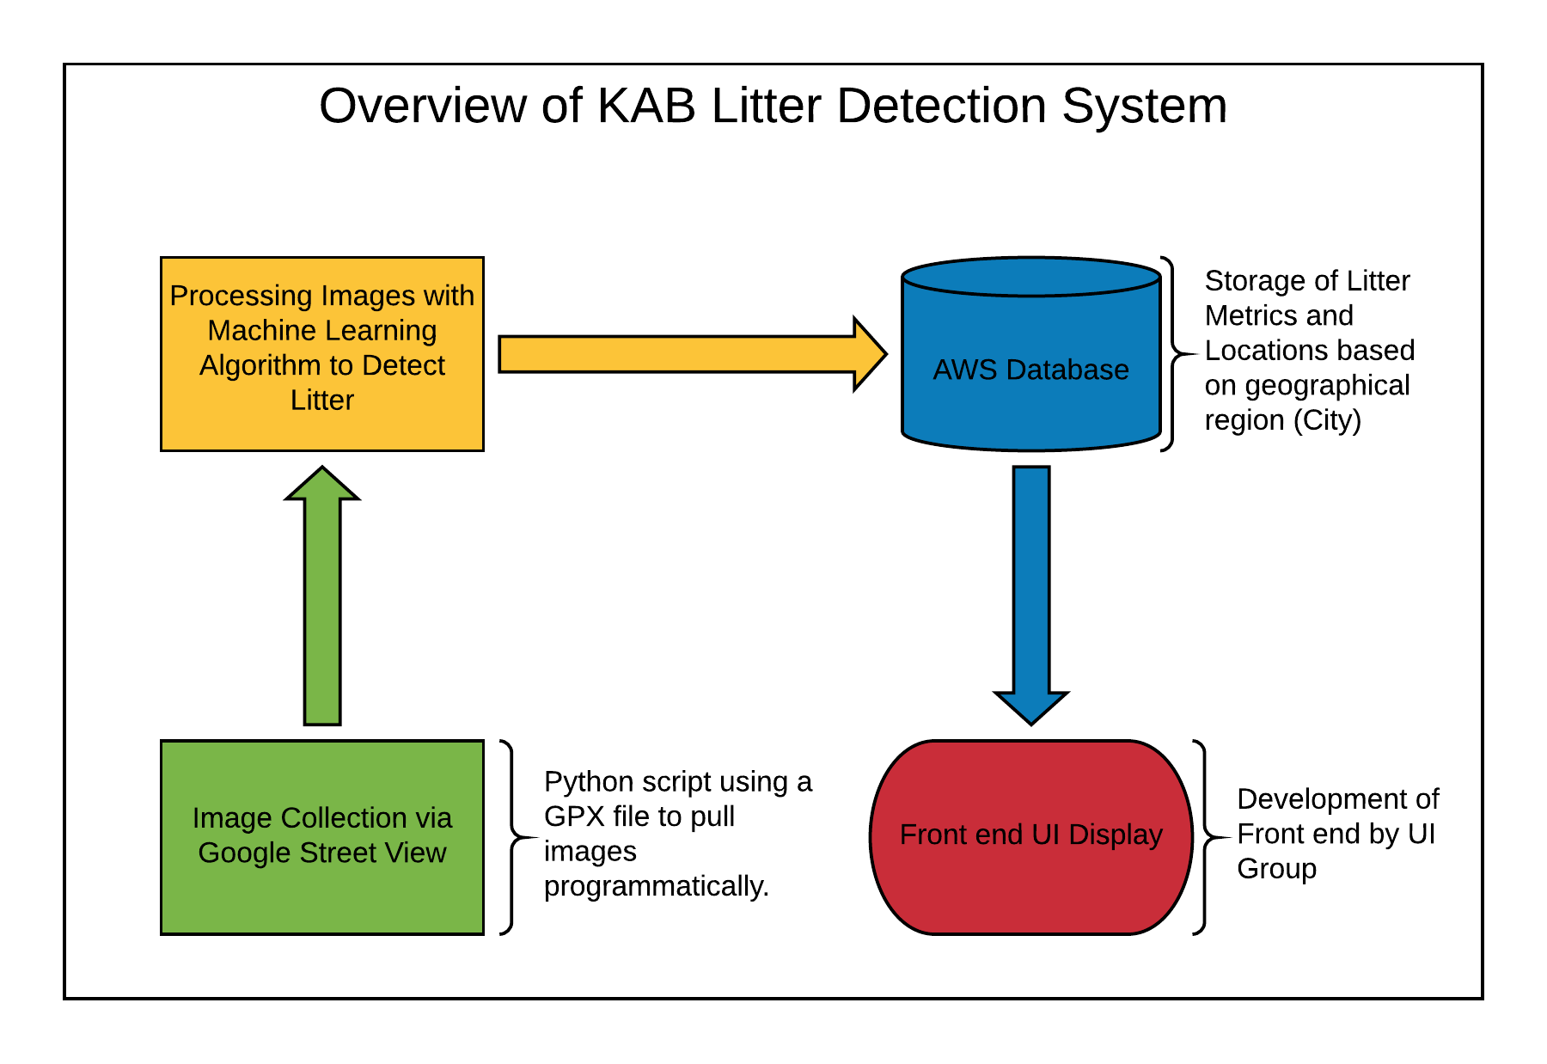

# **2. Requirements Matrix**

|  |  |  |  |  |  |
| --- | --- | --- | --- | --- | --- |
| Req. ID | Requirement | Description | Critical | Implemented [Y/N] | Task ID |
| 1 | Image Collection | - Captured 360 View, Google Maps, Google Street images.  - Python script or student help. | H | N | 5.6, 5.6.1 |
| 2 | Machine Learning Processing | Process images with machine learning algorithm to gather litter metrics. | H | N | 5.6, 5.6.2 |
| 3 | Organize data from algorithm | - Capture data and add it to the database.  - Organized with total litter, litter rating, and geographical location. | H | N | 6.5, 6.5.1, 6.5.2 |
| 4 | Data Accessibility to UI Team | - Litter metrics stored by geographic region for UI team. | H | N | 7.5, 7.5.1 |

# **3. Project Management**

## 3.1 Initial Schedule for Tasks and Deliverables

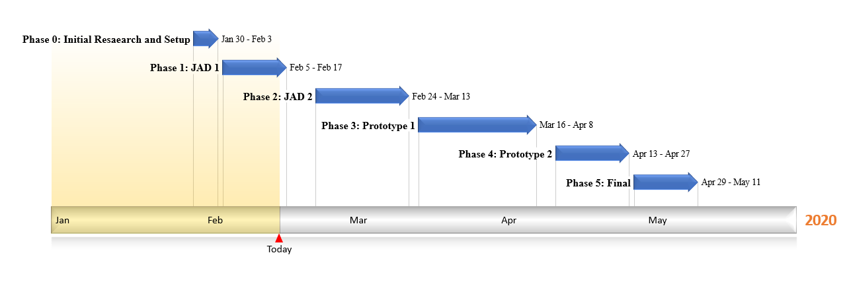

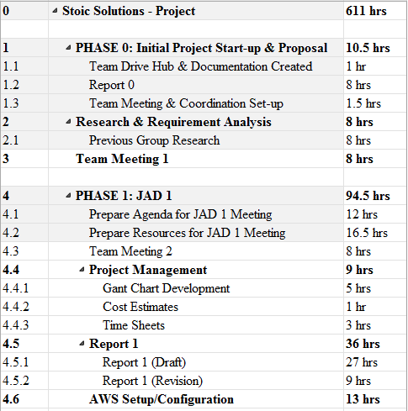

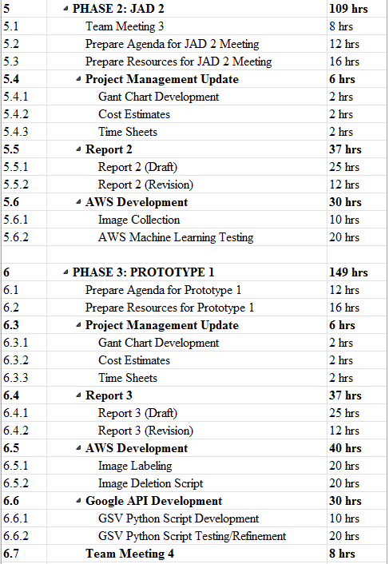

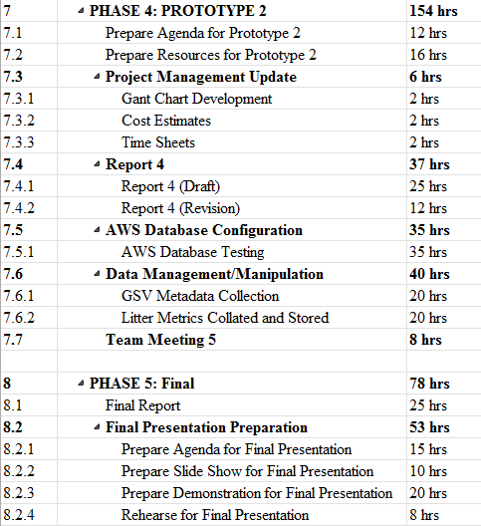

## 3.2 Statement of Total Price

As stated in our initial letter and agreement, the team will be operating at a rate of $28.00 per hour for each member of Stoic Solutions. The AWS server will cost .29 cents per hour to run. Altogether, we estimate this project to cost $17,128.30.

## 3.3 Gantt Chart





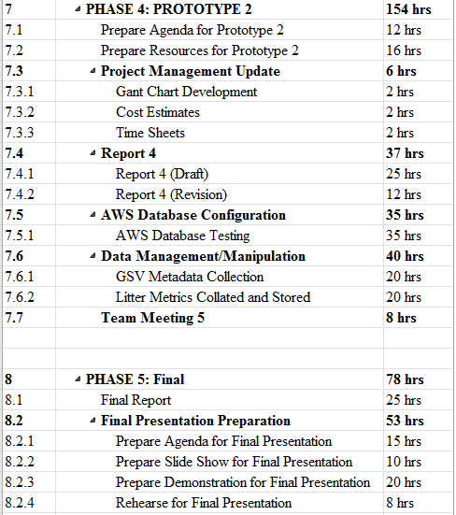

## 3.4 Initial Project Cost Tracking Chart

Below are the costs accumulated based on the team’s total hours worked. AWS was not configured entirely for Phase 0 & 1 but is represented and accrued at later phases.

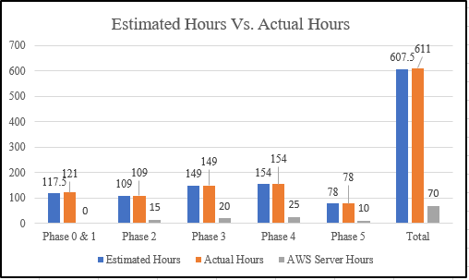

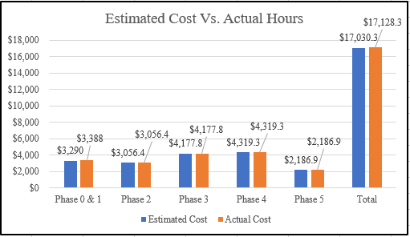

## 3.5 Statement of Deliverables

The Stoic Solutions team strives to deliver the following final products:

* A defined geographic location labelled for each set of 4 images produced from 360 google street images.
* Concise data base filled with litter count in given areas, rating, and geographical location.
* An updated report, including the goals and milestones we’ve reached and all documentation.
* Database documentation and access for UI team to make use of.

## 3.6 Outline of Resources Needed

The following resources are what the Stoic Solutions team will be supplying:

* Extensive Knowledge of AWS and database implementation.
* Updated documentation.
* Research and testing.
* Database credentials and access.

The following resources are what the Stoic Solutions team will need supplied from Dr. Stewart:

* Source code from previous team (Machine learning system).
* AWS Server Instance.
* Possible extra student labour to gather images since we will be doing a 360-view requiring 4 images rather than 1.
* Funding.
* Signage and approval for the Stoic Solutions team to continue working on the project.
* Availability for future meetings.

# **Team Information**

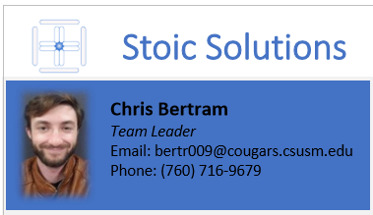

My role on the Stoic Solutions team is Team Leader. My primary role is to facilitate communication between different members of the team and the client(s) to ensure no losses in productivity and maintain continuity and consistency in the product, communication based or otherwise. This includes scheduling meeting times and providing documentation for various communications and workflows.



My primary role on Stoic Solutions is Project Manager. This includes organizing and managing tasks that will take place during the project and making sure that all members have something to work on and contribute to the project. In addition, I will be helping with documentation and making sure every submission and task for the project is completed by the specified date as well as assisting where any other help is needed.



My role within Stoic Solutions is to help administer our new system onto AWS such that it can successfully deliver data to the KAB UI team. Another key responsibility will be ensuring that our data is of the desired format for the UI team. My background is in web development, so I believe that I am well suited for these roles. Along with that, I will be communicating effectively with my team members to ensure that we are on track for all phases of the project.



My primary role in Stoic Solutions is documentation and training, but not limited to anything the team needs help with (Coding, configuring, etc...). My strength/focus is to understand, organize, and present the information given, so that everyone and everything correlates in a timely manner.



My tasks include problem anticipation, system utilization, refinement of abstract ideas, and documentation of the project as we progress. When applicable I will turn useful data or ideas still in the process of being defined, into visual representations. I will float to tasks as assigned by the Project Manager.



My role within Stoic Solutions is to work with our AWS Database and make sure that the UI team can use our data. My strength and focus is understanding data that is created and making it understandable for anyone to use.

My role within the Stoic Solutions team is to review and understand all documentation from the previous team and use my software development experience to add any necessary alterations and improvements so that our project goals are met.

My role in Stoic Solutions will be focused on documentation and training. However, since I have previous experience using Amazon Web Services and Python, I will be helping the team with those aspects as well. I am suited for this role because of my attention to detail and organizational skills. Both of which are required for producing documents that future customers and programmers will find useful. 